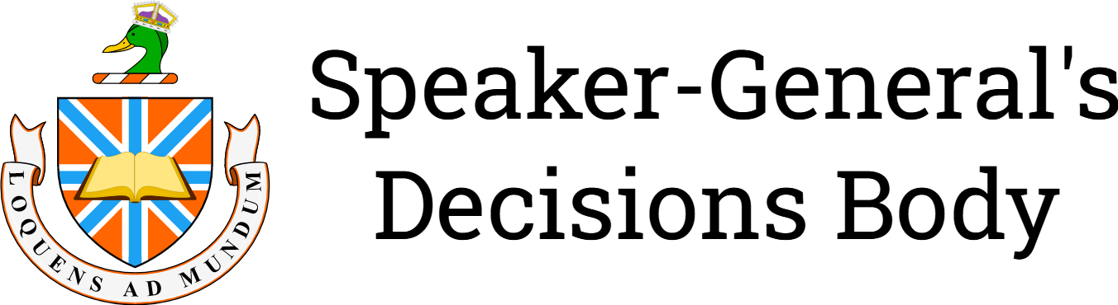

Re Not Attributing an Image of an @ Symbol [2024] SpkGenDec 3
Decision of: | The Speaker-General
Date of decision: | 13 July 2024
Catchwords: | Intellectual property—copyright—attribution—threshold of originality—whether or not a simple image of an @ symbol should be attributed or not.
Number of paragraphs: | 19
DECISION
SGDA2024/003
DECISION MADE BY: THE SPEAKER-GENERAL
DATE OF DECISION: 13 JULY 2024
THE DECISIONS BODY DECIDES THAT:
- No attribution for an the image of an @ symbol uploaded to Wikimedia Commons as File:At-sign.png
- Copyright does not subsist in the @ symbol image uploaded to Wikimedia Commons as File:At-sign.png

REASONS FOR DECISION
THE SPEAKER-GENERAL

Introduction
- Page 20 of lesson document for Module 3 (Module 3 lesson) contains information on writing good e-mails.
- To fill the space on page 20, a picture of an at (@) symbol was used and it also is relevant to the subject of e-mails.
- Angie originally got the image from Wikimedia Commons from the page "File:At-sign.png" (At-sign.png).
- The image was uploaded by a Wikimedia Commons user Livac who claims that the image is their own work (File:At-sign.png, 2023). I find this claim of own work to be dubious.
- There also exists a page named "File:@ symbol.svg" (@ symbol.svg) which at first glance has exactly the same image but as a scalable vector graphic (File:@ symbol.svg, 2024). Looking at the file history, the first version of the file was uploaded by a user named Yug on 26 September 2006. Further revisions of the file were made by the user Johnny Bin which includes fixing the canvas size and converting the @ symbol from text to a path.

Question of Copyright
- Each Wikimedia Commons file has a copyright tag that states its copyright status. Whether it be licensed under a Creative Commons licence or similar copyright licence or if it is in the public domain (either dedicated to the public domain by its author, its copyright has expired or if it is not eligible for copyright).
- At-sign.png has a copyright tag that states it is licensed under the Creative Commons Attribution-Share Alike 4.0 International (CC BY-SA 4.0) licence.
- I say that it should not be licenced under CC BY-SA 4.0 as the image itself is not eligible for copyright.
- Section 6.a of the CC BY-SA 4.0 legal code states that "This Public License applies for the term of the Copyright and Similar Rights licensed here." (Creative Commons, n.d.). I interpret that to mean that if a work is not eligible for copyright, then it does not have a term of copyright, ergo the Creative Commons licence does not apply.
- Creative Commons themselves say on their frequently asked questions page that "CC licences should not be applied to works in the worldwide public domain" (Creative Commons, 2024).
- At-sign.png contains a very basic rendering of an @ symbol. No part of the image contains any authorship, ergo no copyright. The United States Copyright Office (2021, citing Feist Publications, Inc. v Rural Telephone Service Company (1991) 499 US 340) states in section 308.2 that:
A work of authorship must possess "some minimal degree of creativity" to sustain a copyright claim.
- In Australia, the threshold of originality is lower than the United States. Section 32 of the Copyright Act 1968 (Cth) states:

32 Original works in which copyright subsists

(1) Subject to this Act, copyright subsists in an original literary, dramatic, musical or artistic work
…
(2) Subject to this Act, where an original literary, dramatic, musical or artistic work has been published
…
- Case law in Australia for the threshold of originality varies. For artistic works, it is very low. The Australian Aboriginal flag was found to be copyrightable (Harold, Joseph Thomas v Brown, David George and Tennant, James Morrison Vallely 37 IPR 207; [1997] FCA 215) even though it consists of two rectangles, black and red with a yellow circle.
- For literary works, it's higher compared to visual works, in IceTV Pty Limited v Nine Network Australia Pty Limited (2009) 239 CLR 458; [2009] HCA 14 (IceTV v Nine). In the reasons for judgment of French CJ, Crennan and Kiefel JJ held that: "Any reproduction of the time and title information in the IceGuide was not a reproduction of a substantial part of any of the Weekly Schedules (or the Nine Database)" (IceTV v Nineat [56]). Later in the reasons, Gummow, Hayne and Heydon JJ affirmed that:
"there must be a 'creative spark' or exercise of 'skill and judgment' before a work is sufficiently "original" for the subsistence of copyright" (emphasis added; footnotes omitted).
- With the quote in mind, the @ symbol that's in At-sign.png does note have any creative spark and that no skill or judgement was used.
- Give anyone a pen or pencil and they will be able to draw an @ symbol albeit with some variance.
- The @ symbol in At-sign.png would appear to be in an unknown serif typeface. It would be disastrous if a typeface foundry held a monopoly over a simple version of a glyph.
- The original of the @ symbol itself dates back to at least the year 1345 where it appeared in a manuscript (Manasses, 1345). Though, its meaning was different back then. It was used as the initial "a" of the amen formula. So if the symbol itself was copyright—not that copyright in its modern form existed in 1345—it would have expired.

Conclusion
- For those reasons, I find that no attribution is needed for At-sign.png. Through it is generally good practice to properly attribute other people's work to give them credit and to remember where it was retrieved from.

I certify that the preceding nineteen (19) numbered paragraphs are a true copy of the reasons for the decision of the Honourable the Speaker-General.
Signature:
Date: 13 July 2024

References
Copyright Act 1968 (Cth).
Creative Commons. (n.d.). Attribution-Sharealike 4.0 International legal code. https://creativecommons.org/licenses/by-sa/4.0/legalcode.en
Creative Commons. (2024, June 3). Frequently asked questions. https://creativecommons.org/faq/
Feist Publications, Inc. v Rural Telephone Service Company (1991) 499 US 340.
File:@ symbol.svg. (2024, January 14). Wikimedia Commons. https://commons.wikimedia.org/w/index.php?title=File:@_symbol.svg&oldid=841404403.
File:At-sign.png. (2023, September 28). Wikimedia Commons. https://commons.wikimedia.org/w/index.php?title=File:At-sign.png&oldid=805794175
Harold, Joseph Thomas v Brown, David George and Tennant, James Morrison Vallely 37 IPR 207; [1997] FCA 215.
IceTV Pty Limited v Nine Network Australia Pty Limited (2009) 239 CLR 458; [2009] HCA 14.
Manasses, C. (1345). Escape of Paris and Helen and the beginning of the Trojan War. Constantine Manasses Chronicle. miniature 19. https://commons.wikimedia.org/wiki/File:19-manasses-chronicle.jpg
United States Copyright Office. (2021). Compendium of United States Copyright Office practices (3rd ed.).

